Spring :

It is **developed by Rod Johnson in 2003**.

1. Spring is dependency injection framework to make java application loosely coupled.

2. It used to make java EE application.

Tightly coupled : if module build then we are not able to change that module.

Loosely coupled: if module is build we can easily change any component.

**SPRING CORE ::::::::**

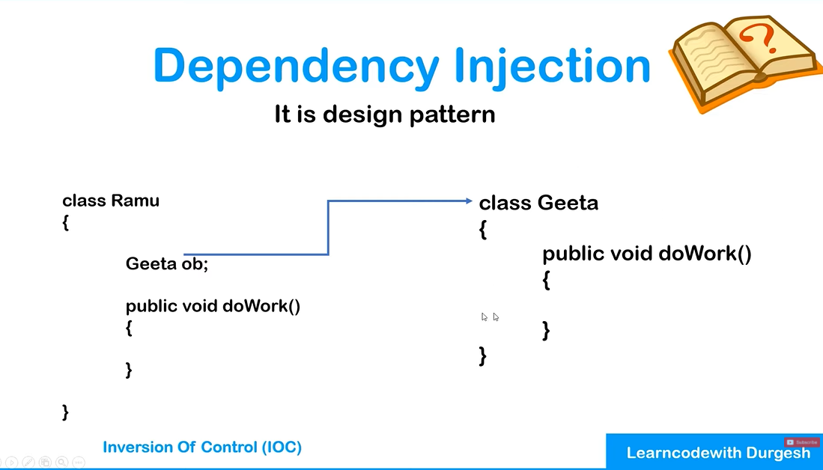

Dependency injection :This is like design pattern. It is basically used when one class depend upon other class. We required other class object inside first class. We don’t required to create object manually of other class. Spring dependency injection will done automatically creation of object.

Inversion of control: It is process to make application loosely coupled with help of dependency injection.

Dependency injection can be done in two ways:

1. setter dependency injection:

In this injection IOC container automatically call set method for respective variable ex. Address class has city variable the IOC will have setcity(){} method call automatically. Onces object is created IOC will inject this object inside Student class.

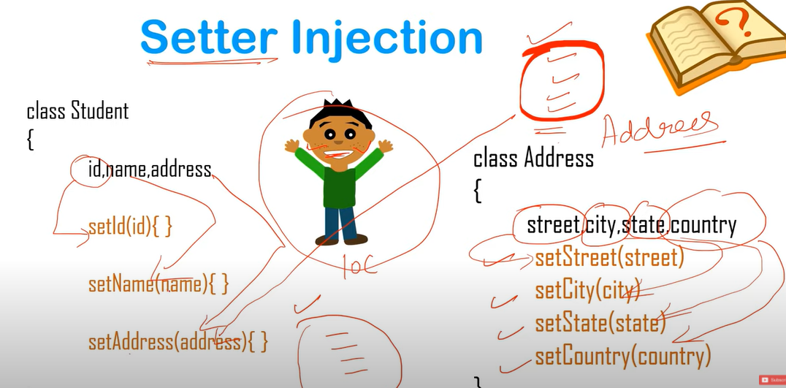

2. constructor dependency

This is type we have created constructor and and make object and pass into Student class This all done by IOC.

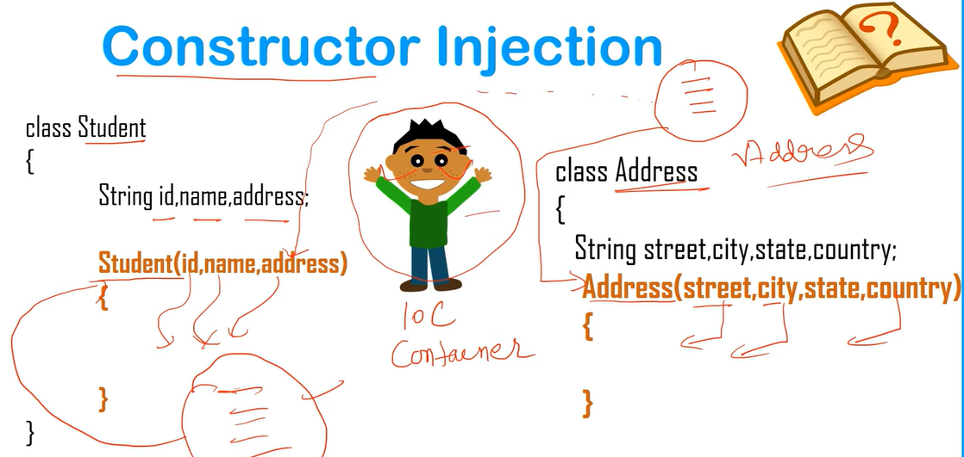

If you make your object with your own then it will become tightly coupled.

1. spring core 2. Spring JDBC 3. Spring MVC 4. Spring ORM

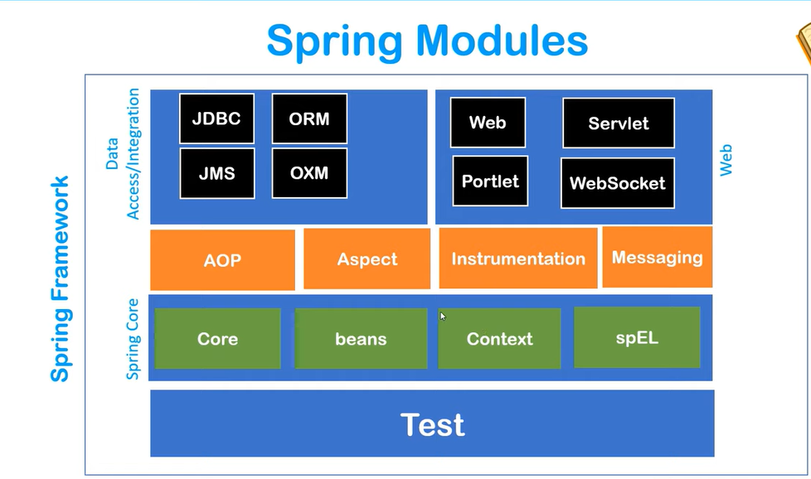

Spring IOC container : It is process in which holding objects in memory and used to inject that object in required class.

It requires two things Beans and configuration -> POJO class and xml config file so that required class can get pojo methods easily.

Process can be done by applicationcontext

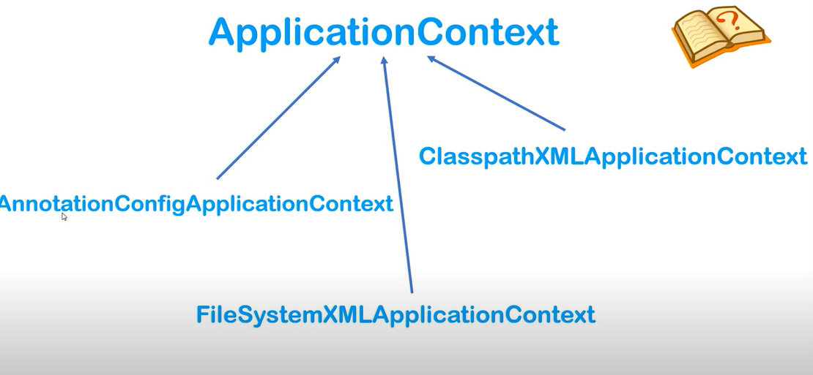

Classpathxml…. -> It actually finds xml configuration by class path.

AnnotationConfig.. -> It actually find annotation in java bean for build xml config.

FileSystem… -> It build xml config by filesystem.

IOC can be handle data types:

1. primitive data type 2. Collection 3. Refence type.(object userdefine)

……………………………………………………………………………………………………………….

1. spring core and 2. Spring context – add in pom.xml from MVN Repo

2. create student Java beans - > setter and getter method inside class.

3. create configuration file -> config.xml (right click to java folder ->other->xml file)

4. Add this configuration in file. -> used setter dependency injection(primitive type)

<?xml version=*"1.0"* encoding=*"UTF-8"*?>

<beans xmlns=*"http://www.springframework.org/schema/beans"*

xmlns:xsi=*"http://www.w3.org/2001/XMLSchema-instance"*

xmlns:context=*"http://www.springframework.org/schema/context"*

xmlns:p=*"http://www.springframework.org/schema/p"*

xsi:schemaLocation=*"http://www.springframework.org/schema/beans*

*http://www.springframework.org/schema/beans/spring-beans.xsd*

*http://www.springframework.org/schema/context*

*http://www.springframework.org/schema/context/spring-context.xsd"*>

<bean class=*"com.spring.springcore.Student"* name=*"student1"*>

<property name=*"StudId"*>

<value>101</value>

</property>

<property name=*"StudName"*>

<value>Ajay Ingle</value>

</property>

<property name=*"StudAddress"*>

<value>Mumbai</value>

</property>

</bean>

</beans>

**In main method:**

ApplicationContext context =

**new** ClassPathXmlApplicationContext("config.xml");

Student student1 = (Student) context.getBean("student1");

System.***out***.println(student1);

Do value as attribute in beans:

<bean class=*"com.spring.springcore.Student"* name=*"student1"*>

<property name=*"StudId"* value=*"101"* />

<property name=*"StudName"* value=*"Ajay Ingle"* />

<property name=*"StudAddress"* value=*"Mumbai"* />

</bean>

<bean class=*"com.spring.springcore.Student"* name=*"student2"*>

<property name=*"StudId"* value=*"102"* />

<property name=*"StudName"* value=*"Vijay Ingle"* />

<property name=*"StudAddress"* value=*"Delhi"* />

</bean>

**Do value as P schema :**

<bean class=*"com.spring.springcore.Student"* name=*"student1"* p:StudId=*"101"* p:StudName=*"Ajay Ingle"* p:StudAddress=*"Mumbai"*/>

<bean class=*"com.spring.springcore.Student"* name=*"student2"* p:StudId=*"102"* p:StudName=*"Vijay Ingle"* p:StudAddress=*"Delhi"*/>

used setter dependency injection(collection type)

<bean name=*"emp1"* class=*"com.spring.collection.Employee"*>

<property name=*"name"* value=*"Gunda"*></property>

<property name=*"phones"*>

<list>

<value>123</value>

<value>456</value>

</list>

</property>

<property name=*"addresses"*>

<set>

<value>Delhi</value>

<value>Mumbai</value>

</set>

</property>

<property name=*"courses"*>

<map>

<entry key=*"java"* value=*"3/m"*/>

<entry key=*"django"* value=*"2/m"*/>

</map>

</property>

</bean>

ApplicationContext context = **new** ClassPathXmlApplicationContext("com/spring/collection/empconfig.xml");

Employee emp1 = (Employee) context.getBean("emp1");

System.***out***.println(emp1.getName() + " " + emp1.getAddresses()+ " " + emp1.getCourses() + " "+ emp1.getPhones());

used setter dependency injection(reference type)

<bean class=*"com.spring.referencetype.Vijay"* name=*"vref"*>

<property name=*"y"* value=*"100"*/>

</bean>

<bean class=*"com.spring.referencetype.Ajay"* name=*"aref"* p:v-ref=*"vref"* p:x=*"300"*/>

<!-- <property name="x" value="200"/> -->

<!-- <property name="v">

<ref bean="vref"/>

</property> -->

<!-- <property name="v" ref="vref"/> -->

ApplicationContext context = **new** ClassPathXmlApplicationContext("com/spring/referencetype/ref.xml");

Ajay a = (Ajay) context.getBean("aref");

System.***out***.println(a.getX() + " " + a.getV() + " " + a.getV().getY() );

Constructor used : with all data types –

<?xml version=*"1.0"* encoding=*"UTF-8"*?>

<beans xmlns=*"http://www.springframework.org/schema/beans"*

xmlns:xsi=*"http://www.w3.org/2001/XMLSchema-instance"*

xmlns:context=*"http://www.springframework.org/schema/context"*

xmlns:p=*"http://www.springframework.org/schema/p"*

xmlns:c=*"http://www.springframework.org/schema/c"*

xsi:schemaLocation=*"http://www.springframework.org/schema/beans*

*http://www.springframework.org/schema/beans/spring-beans.xsd*

*http://www.springframework.org/schema/context*

*http://www.springframework.org/schema/context/spring-context.xsd"*>

<bean class=*"com.spring.constructor.Address"* name=*"address"* c:city=*"Delhi"* c:state=*"gujrat"*>

<!-- <constructor-arg value="Maharashatra" />

<constructor-arg value="Mumbai" /> -->

<constructor-arg>

<set>

<value>30</value>

<value>40</value>

</set>

</constructor-arg>

</bean>

<bean class=*"com.spring.constructor.Person"* name=*"person"*>

<constructor-arg value=*"ingleajay"*/>

<constructor-arg value=*"101"* type=*"int"*/>

<constructor-arg ref=*"address"* />

<constructor-arg>

<list>

<value>Django</value>

<value>Java</value>

</list>

</constructor-arg>

<constructor-arg>

<map>

<entry key=*"COA"*><value>80</value></entry>

<entry key=*"DSA"*><value>90</value></entry>

<entry key=*"DBMS"*><value>100</value></entry>

</map>

</constructor-arg>

</bean>

</beans>

ApplicationContext context = **new** ClassPathXmlApplicationContext("com/spring/constructor/constructor.xml");

Person p = (Person) context.getBean("person");

System.***out***.println(p);

Constructor problem :

Spring search value as string if constructor has string value then it is called first otherwise whoever is first constructor created it will called or you can also give in bean class manually type of your value inside constructor args.

spring beans life cycle methods :

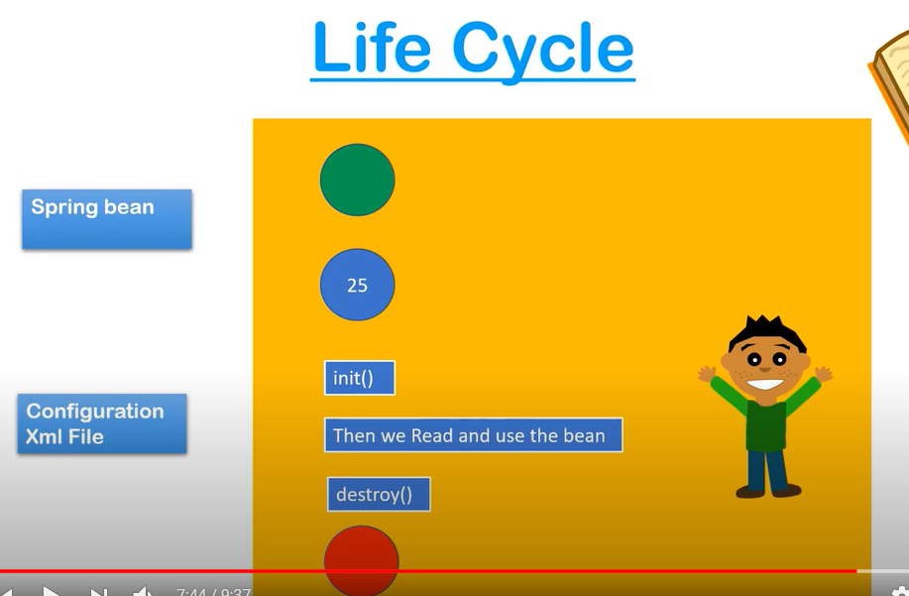

init and destroy method can be override but signature must be same means public void you can not change.

It can be done in three ways:

1. by xml-(AbstractApplication context) :

Write inside your pojo class

**public** **void** init() {

System.***out***.println("Inside init method");

}

**public** **void** destroy() {

System.***out***.println("Inside destory method");

}

your xml

<bean name=*"s1"* class=*"com.spring.lifecycle.Samosa"* p:price=*"10"* init-method=*"init"* destroy-method=*"destroy"*/>

your main class

AbstractApplicationContext context = **new** ClassPathXmlApplicationContext("com/spring/lifecycle/config.xml");

Samosa s1 = (Samosa)context.getBean("s1");

System.***out***.println(s1);

context.registerShutdownHook();

2. by interface –(intializing bean ,disposable bean)

**public** **class** Pepsi **implements** InitializingBean , DisposableBean {

**public** **void** afterPropertiesSet() **throws** Exception {

// **TODO** Auto-generated method stub

System.***out***.println("init is running....");

}

**public** **void** destroy() **throws** Exception {

// **TODO** Auto-generated method stub

System.***out***.println("destoy is running....");

}

}

Xml :

<bean name=*"p1"* class=*"com.spring.lifecycle.Pepsi"* p:price=*"50"* />

AbstractApplicationContext context = **new** ClassPathXmlApplicationContext("com/spring/lifecycle/config.xml");

Pepsi p1 = (Pepsi)context.getBean("p1");

System.***out***.println(p1);

context.registerShutdownHook();

3. using annotation - (@PostConstruct, @PreDestroy)

<dependency>

<groupId>javax.annotation</groupId>

<artifactId>javax.annotation-api</artifactId>

<version>1.3.2</version>

</dependency>

//import javax.annotation.PostConstruct;

//import javax.annotation.PreDestroy;

//@PostConstruct

**public** **void** start() {

System.***out***.println("Start init method..");

}

//@PreDestroy

**public** **void** end() {

System.***out***.println("End destroy method..");

}

<context:annotation-config/>

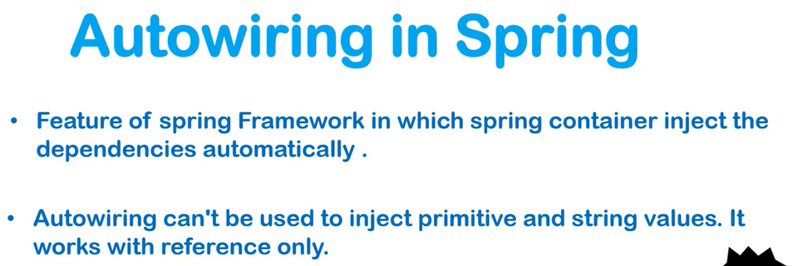

It is only applicable to object not to any data type

Automatic wiring is basically inject one object of class to another class automatically.

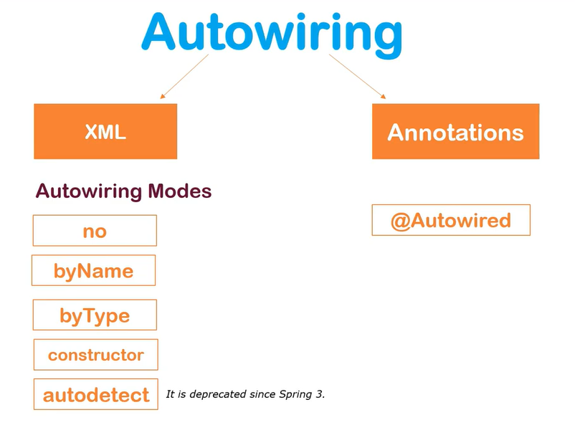

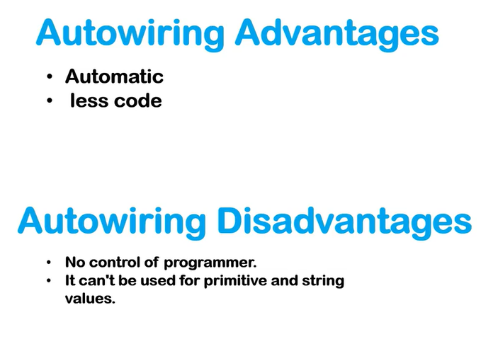

Autowiring is done by xml -> byName, byType , constructor

<bean class=*"com.spring.auto.wire.Address"* name=*"address"* p:city=*"Mumbai"* p:street=*"Chembur"* />

<bean class=*"com.spring.auto.wire.Emp"* name=*"emp1"* autowire=*"byType"* />

<!-- or -->

<bean class=*"com.spring.auto.wire.Emp"* name=*"emp1"* autowire=*"byName"* />

<!-- or -->

<bean class=*"com.spring.auto.wire.Emp"* name=*"emp1"* autowire=*"constructor"* />

ApplicationContext context = **new** ClassPathXmlApplicationContext("com/spring/auto/wire/config.xml");

Emp emp1 = context.getBean("emp1",Emp.**class**);

System.***out***.println(emp1);

Autowiring is done by annotation -> on property, on constructor, on method

**import** org.springframework.beans.factory.annotation.Autowired;

@Autowired

**private** Address address;

<context:annotation-config/>

<bean class=*"com.spring.auto.wire.annotation.Address"* name=*"address"* p:city=*"Mumbai"* p:street=*"Chembur"* />

<bean class=*"com.spring.auto.wire.annotation.Emp"* name=*"emp2"* />

You can put @Autowired on set method and constructor as well

@Qualifier("address1")

Qualifier is basically for which bean you want to used for object injection.

Spring Standalone collection –

You have specified your list in one of the property but you want to used that in other property too. So that we need to make that list or any collection value as global throughout of beans. So that you can access value within any scope of property.

<?xml version=*"1.0"* encoding=*"UTF-8"*?>

<beans xmlns=*"http://www.springframework.org/schema/beans"*

xmlns:xsi=*"http://www.w3.org/2001/XMLSchema-instance"*

xmlns:context=*"hhtp://www.springframework.org/schema/context"*

xmlns:p=*"http://www.springframework.org/schema/p"*

xmlns:util=*"http://www.springframework.org/schema/util"*

xsi:schemaLocation=*"http://www.springframework.org/schema/beans*

*http://www.springframework.org/schema/beans/spring-beans.xsd*

*http://www.springframework.org/schema/context*

*http://www.springframework.org/schema/context/spring-context.xsd*

*http://www.springframework.org/schema/util*

*http://www.springframework.org/schema/util/spring-util.xsd*

*"*>

<util:list list-class=*"java.util.LinkedList"* id=*"mf"*>

<value>Ajay</value>

<value>Vijay</value>

<value>Sonali</value>

</util:list>

<util:map map-class=*"java.util.HashMap"* id=*"ff"*>

<entry key=*"java"* value=*"100"*/>

<entry key=*"django"* value=*"300"*/>

<entry key=*"hibernate"* value=*"2000"*/>

</util:map>

<bean class=*"com.spring.standalone.collections.Person"* name=*"p1"* >

<property name=*"friends"* ref=*"mf"* />

<property name=*"feestr"* ref = *"ff" /*>

</bean>

</beans>

ApplicationContext context = **new** ClassPathXmlApplicationContext("com/spring/standalone/collections/config.xml");

Person p = (Person) context.getBean("p1");

System.***out***.println(p + p.getFriends().getClass().getName());

System.***out***.println(p.getFeestr() + p.getFeestr().getClass().getName());

-Use stereotypes annotation – @Component and @Value

Stereotypes annotation is useful when we don’t want to create any bean file. Without bean also we can get and create object of class.

<context:component-scan base-package=*"com.spring.sterotypes"* />

ApplicationContext context = **new** ClassPathXmlApplicationContext("com/spring/sterotypes/config.xml");

Student student = (Student) context.getBean("student");

System.***out***.println(student);

@Component

**public** **class** Student {

@Value("1001")

**private** **int** StudId;

@Value("sanju")

**private** String StudName;

@Value("chennai")

**private** String StudAddress;

………………

}

class. Here you can also give your own object name .IOC will generate object like class name in lower case.

@Component(“obj”)

How can we create object of collection in stereotypes :

<util:list list-class=*"java.util.ArrayList"* id=*"t1"*>

<value>Mumbai</value>

<value>delhi</value>

<value>gujrat</value>

<value>lauckanow</value>

<value>chennai</value>

</util:list>

@Value("#{t1}")

**private** List<String> StudAddress;

Bean scope : singleton, prototype, (request, session, globalsession -> web mvc)

Singleton -> Spring IOC create only one object every time for all.

Prototype -> Spring IOC create new object every time for all.

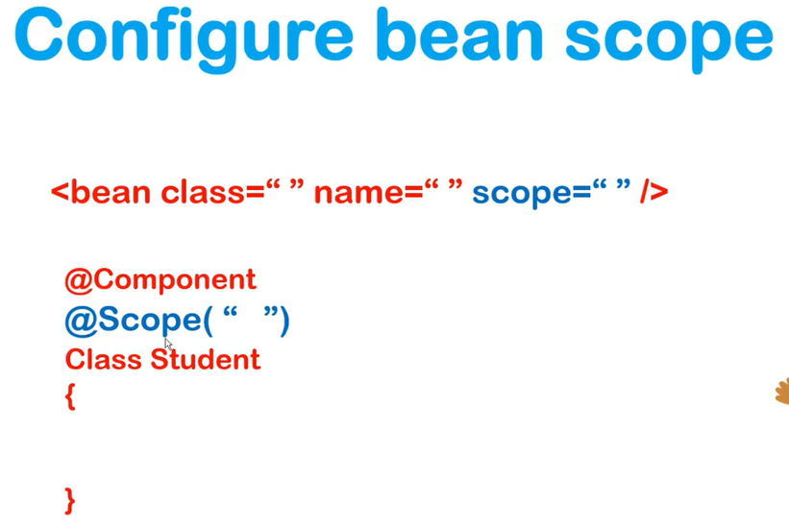

Check : Student s = (Student) context.getBean("ob");

System.***out***.println("obj1:" + s.hashCode());

Student s1 = (Student) context.getBean("ob");

System.***out***.println("obj2 :" + s1.hashCode());

@Scope("prototype")

Spring Expression Language :

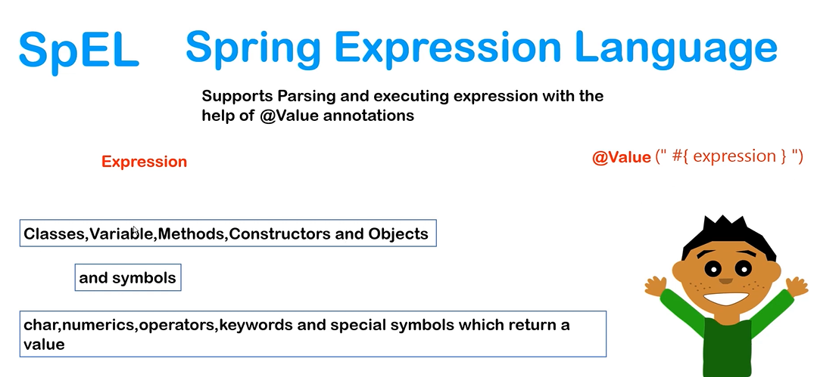

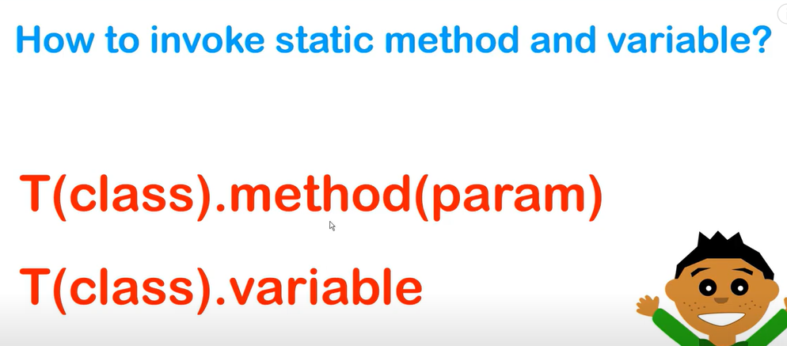

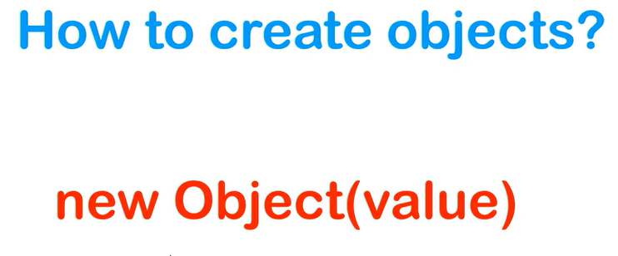

Remove Xml file.

Use annotation :

@Bean -> It used to remove @component and done all configuration inside java configuration

@ComponentScan -> if you are using @Bean then it is not neccssary to used . it used for define base package inside java config file.

@Configuration -> Indicate that file is configuration file .

Emp ->

**package** com.spring.removeconfig;

**import** java.util.List;

**import** java.util.Map;

**import** org.springframework.beans.factory.annotation.Autowired;

**import** org.springframework.beans.factory.annotation.Qualifier;

**import** org.springframework.beans.factory.annotation.Value;

**public** **class** Employee {

@Value("jay")

**private** String ename;

@Autowired

@Qualifier("lemp")

**private** List<Integer> rate;

@Autowired

@Qualifier("memp")

**private** Map<String,Integer> marks;

**static** **void** display2() {

System.***out***.println("I am prititng..emp");

}

**public** Map<String, Integer> getMarks() {

**return** marks;

}

**public** **void** setMarks(Map<String, Integer> marks) {

**this**.marks = marks;

}

**public** String getEname() {

**return** ename;

}

**public** **void** setEname(String ename) {

**this**.ename = ename;

}

@Override

**public** String toString() {

**return** "Employee [ename=" + ename + ", rate=" + rate + ", marks=" + marks + "]";

}

**public** List<Integer> getRate() {

**return** rate;

}

**public** **void** setRate(List<Integer> rate) {

**this**.rate = rate;

}

}

Student ->

**package** com.spring.removeconfig;

**import** org.springframework.stereotype.Component;

@Component("stu")

**public** **class** Student {

**static** **void** display() {

System.***out***.println("I am prititng..");

}

}

Main method ->

// **TODO** Auto-generated method stub

ApplicationContext c = **new** AnnotationConfigApplicationContext(JavaConfig.**class**);

Student d = c.getBean("stu",Student.**class**);

Employee e = c.getBean("emp1",Employee.**class**);

d.*display*();

e.*display2*();

System.***out***.println(e.getEname());

System.***out***.println(e.getRate());

System.***out***.println(e.getMarks());

}

Java config **package** com.spring.removeconfig;

**import** java.util.Arrays;

**import** java.util.HashMap;

**import** java.util.List;

**import** java.util.Map;

**import** org.springframework.beans.factory.annotation.Value;

**import** org.springframework.context.annotation.Bean;

**import** org.springframework.context.annotation.ComponentScan;

**import** org.springframework.context.annotation.Configuration;

@Configuration

@ComponentScan(basePackages="com.spring.removeconfig")

**public** **class** JavaConfig {

@Bean(name= {"emp1"})

**public** Employee getEmp() {

**return** **new** Employee();

}

@Bean(name= {"lemp"})

**public** List<Integer> rateList() {

**return** Arrays.*asList*(1,2,3,4,5);

}

@Bean(name= {"memp"})

**public** Map<String,Integer> marksMap() {

Map<String,Integer> mMap = **new** HashMap<String,Integer>();

mMap.put("DSA",100);

mMap.put("COA",89);

mMap.put("DBMS",60);

**return** mMap;

}

}

->

Spring JDBC :

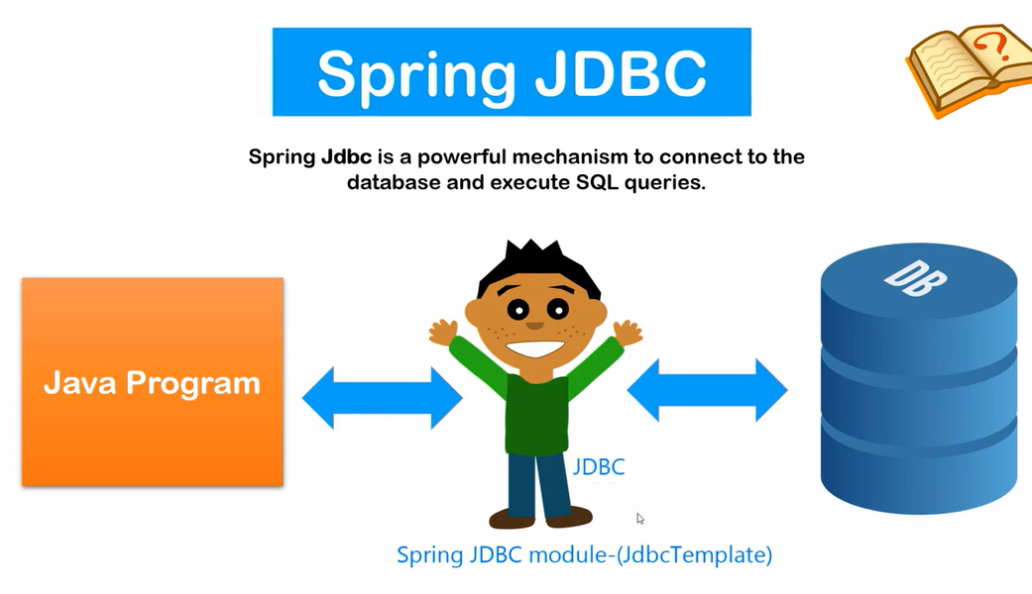

Problems of jdbc :

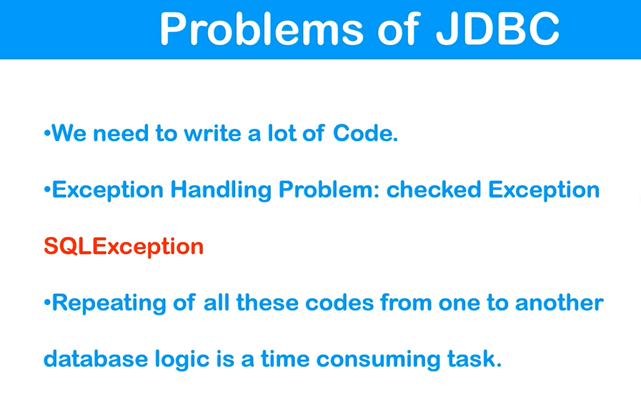

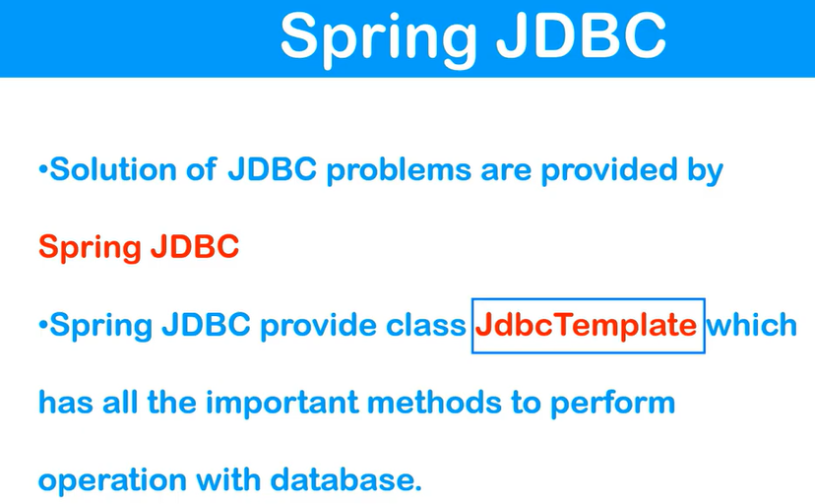

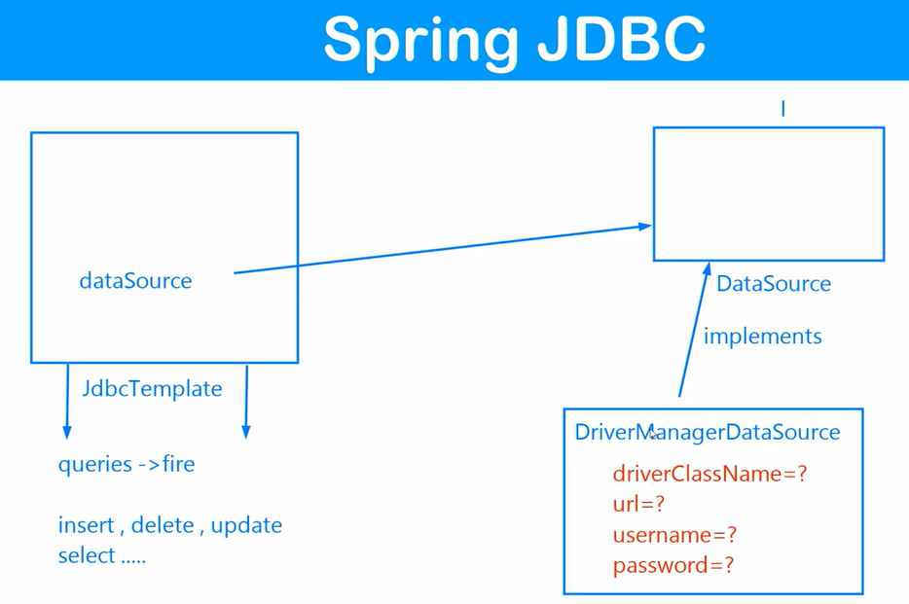

pom :

install 4 dependecy – 2 spring, 1-mysql, 1-spring jdbc

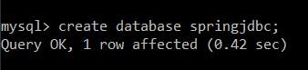



With xml :

<bean class=*"org.springframework.jdbc.datasource.DriverManagerDataSource"*

name=*"ds"*

p:driverClassName=*"com.mysql.jdbc.Driver"*

p:url=*"jdbc:mysql://localhost:3307/springjdbc"*

p:username=*"root"*

p:password=*"xxxxxxxx"*

/>

<bean class=*"org.springframework.jdbc.core.JdbcTemplate"*

name=*"jdbcTemplate"*

p:dataSource-ref=*"ds"*/>

<bean class=*" com.spring.Jdbc.dao.StudentDaoImplement"*

name=*"studentDao"*

p:jdbcTemplate-ref=*"jdbcTemplate"*

/>

Structure of folder :

Main package , configuration xml file package, dao package, modal/ bean/ entity package.

Create bean -> JDBC config -> interface dao -> implement interface dao -> App class

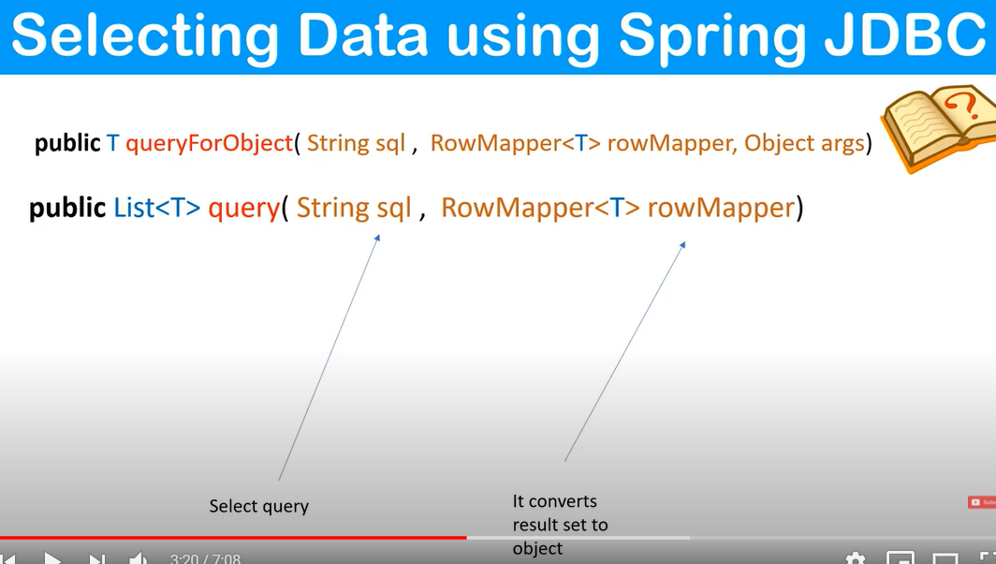

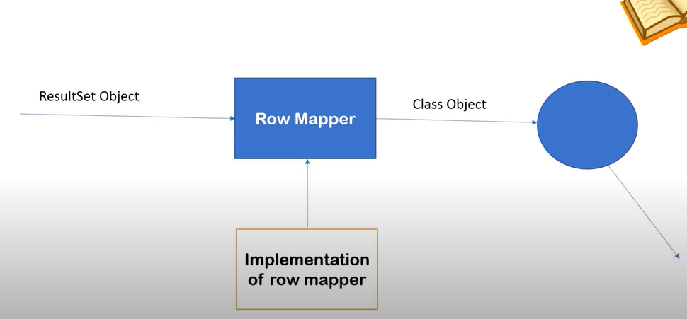

Rowmapper is used to convert resultset into objects of class. It means one object tends to one row mapping. Row mapper will do this the help of implementation of row mapper.

Project steps :

1. Add all dependency in pom file. (4) – spring-core, spring-context, spring-jdbc , mysql connector.

2. first package for main app

3. second package for config xml

4. third package for dao interface

5. fourth package for pojo

6. setup config –

<?xml version=*"1.0"* encoding=*"UTF-8"*?>

<beans

xmlns=*"http://www.springframework.org/schema/beans"*

xmlns:xsi=*"http://www.w3.org/2001/XMLSchema-instance"*

xmlns:context=*"http://www.springframework.org/schema/context"*

xmlns:p=*"http://www.springframework.org/schema/p"*

xsi:schemaLocation=*"http://www.springframework.org/schema/beans*

*http://www.springframework.org/schema/beans/spring-beans.xsd*

*http://www.springframework.org/schema/context*

*http://www.springframework.org/schema/context/spring-context.xsd"*

>

<bean class=*"org.springframework.jdbc.datasource.DriverManagerDataSource"*

name=*"ds"*

p:driverClassName=*"com.mysql.cj.jdbc.Driver"*

p:url=*"jdbc:mysql://localhost:3307/springjdbc"*

p:username=*"root"*

p:password=*"Lufa@7917"*

/>

<bean class=*"org.springframework.jdbc.core.JdbcTemplate"*

name=*"jdbcTemplate"*

p:dataSource-ref=*"ds"*/>

</beans>

7. setup all pojo class

8. make all table in mysql

Spring ORM

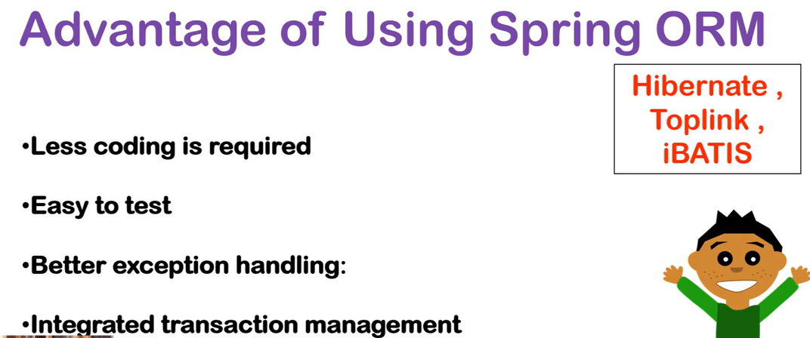

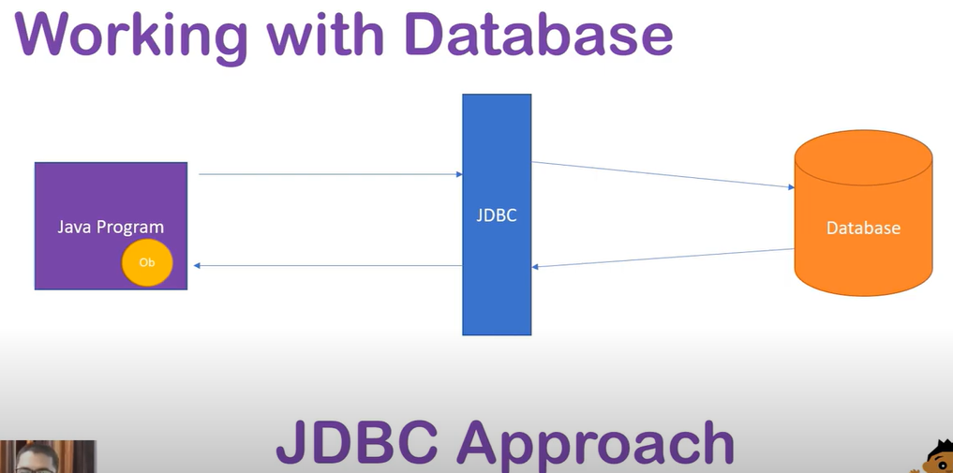

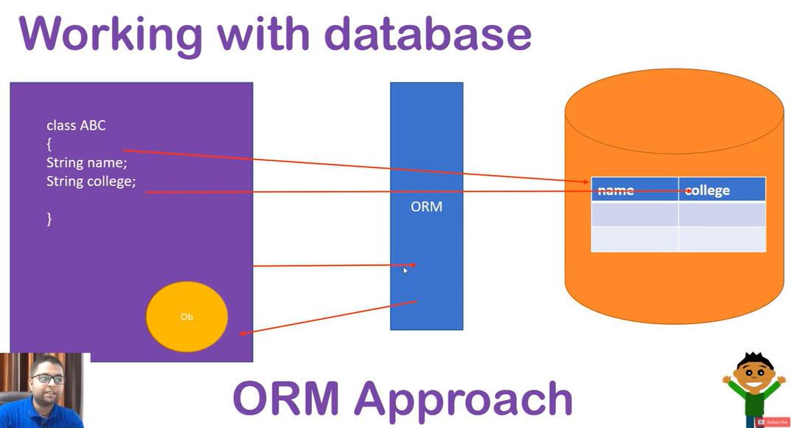

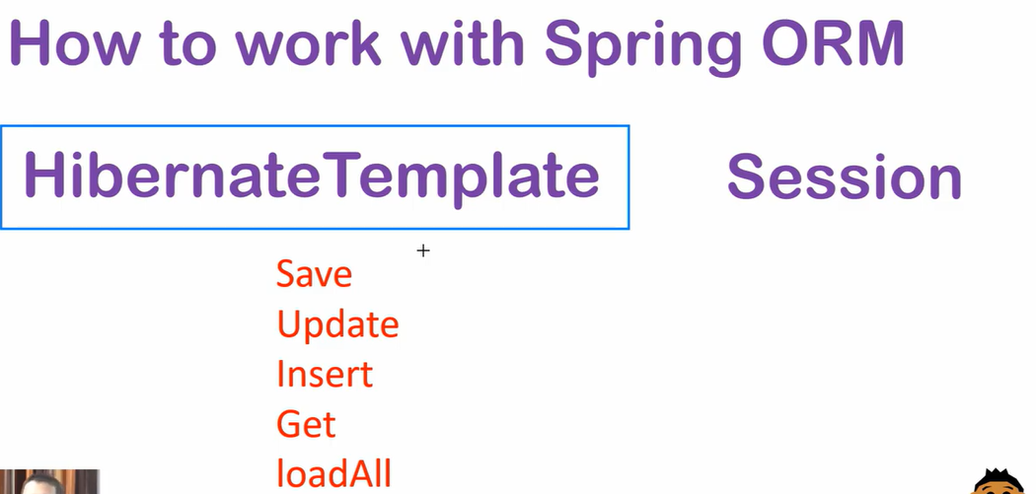

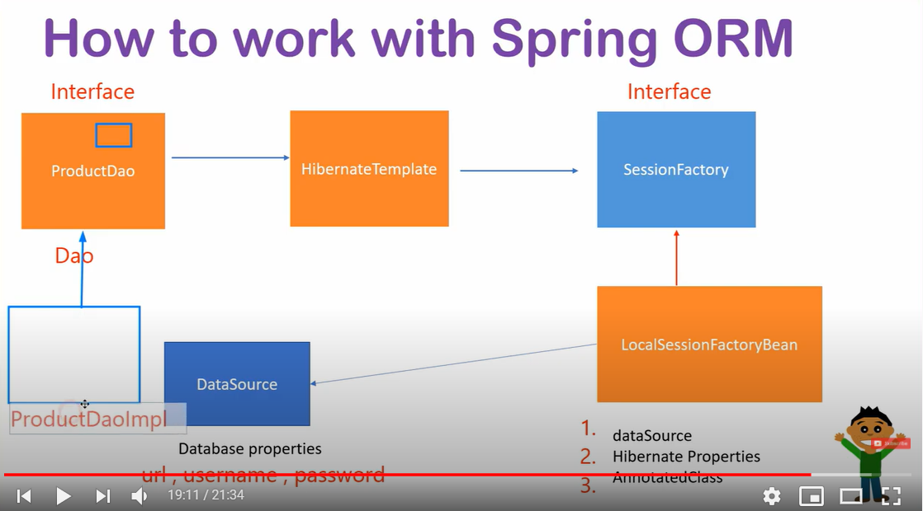

Pom – 5 dependency – spring core, orm, context, mysql,hibernate-core

@Entity - > class is mapped to table

@Table -> create table with specific name

@Column -> give column name

@Transactional -> used to write operations in db

@Id – to make attribute primary key

@OneToOne – make mapping one to one only

@OnDelete – if one of table is record is delete then other table also delete corresponding record.

To view implementation use ctrl+shift+T in eclipse

This all configuration of hibernate spring

<?xml version=*"1.0"* encoding=*"UTF-8"*?>

<beans xmlns=*"http://www.springframework.org/schema/beans"*

xmlns:xsi=*"http://www.w3.org/2001/XMLSchema-instance"*

xmlns:context=*"http://www.springframework.org/schema/context"*

xmlns:p=*"http://www.springframework.org/schema/p"*

xmlns:tx=*"http://www.springframework.org/schema/tx"*

xmlns:util=*"http://www.springframework.org/schema/util"*

xsi:schemaLocation=*"http://www.springframework.org/schema/beans*

*http://www.springframework.org/schema/beans/spring-beans.xsd*

*http://www.springframework.org/schema/context*

*http://www.springframework.org/schema/context/spring-context.xsd*

*http://www.springframework.org/schema/util*

*http://www.springframework.org/schema/util/spring-util.xsd*

*http://www.springframework.org/schema/tx*

*http://www.springframework.org/schema/tx/spring-tx.xsd*

*"*>

<tx:annotation-driven/>

<bean class=*"org.springframework.jdbc.datasource.DriverManagerDataSource"*

name=*"ds"*

p:driverClassName=*"com.mysql.cj.jdbc.Driver"*

p:url=*"jdbc:mysql://localhost:3307/springjdbc"*

p:username=*"root"*

p:password=*"Lufa@7917"*

/>

<bean class=*"org.springframework.orm.hibernate5.LocalSessionFactoryBean"* name=*"factory"*>

<!-- data source -->

<property name=*"dataSource"* ref=*"ds"* ></property>

<!-- hibernate three properties -->

<property name=*"hibernateProperties"*>

<props>

<prop key=*"hibernate.dialect"*>org.hibernate.dialect.MySQL8Dialect</prop>

<prop key=*"hibernate.show_sql"*>true</prop>

<prop key=*"hibernate.hbm2ddl.auto"*>update</prop>

</props>

</property>

<!-- annoted classes -->

<property name=*"annotatedClasses"*>

<list>

<value>

com.spring.orm.pojo.Student

</value>

</list>

</property>

</bean>

<bean

class=*"org.springframework.orm.hibernate5.HibernateTemplate"*

name=*"hibernateTemplate"*>

<property name=*"sessionFactory"* ref=*"factory"*></property>

</bean>

<bean class=*"com.spring.orm.dao.StudentDao"* name=*"studentDao"*>

<property name=*"hibernateTemplate"* ref=*"hibernateTemplate"*></property>

</bean>

<bean class=*"org.springframework.orm.hibernate5.HibernateTransactionManager"* name=*"transactionManager"*>

<property name=*"sessionFactory"* ref=*"factory"*></property>

</bean>

</beans>

Spring MVC

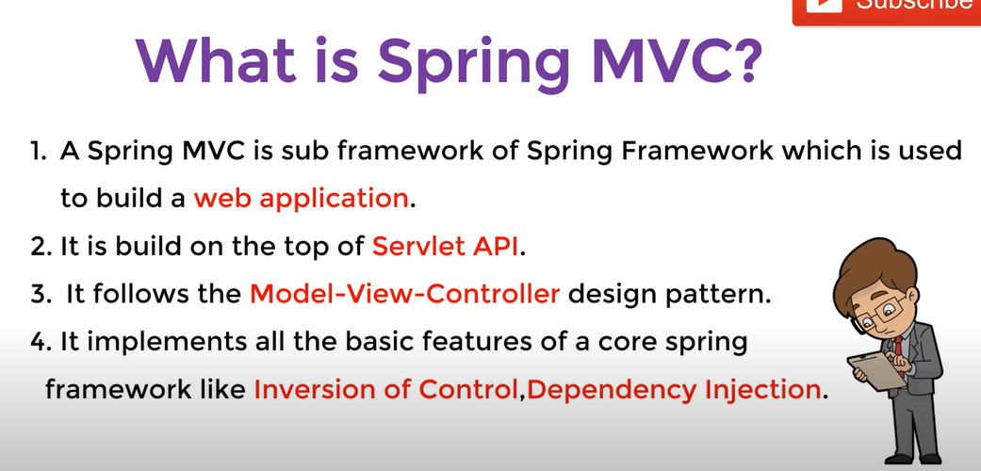

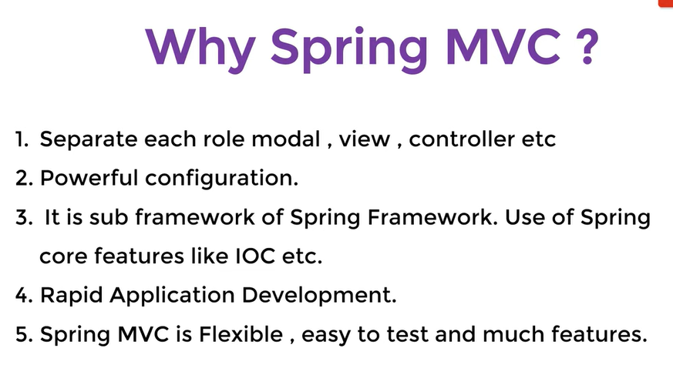

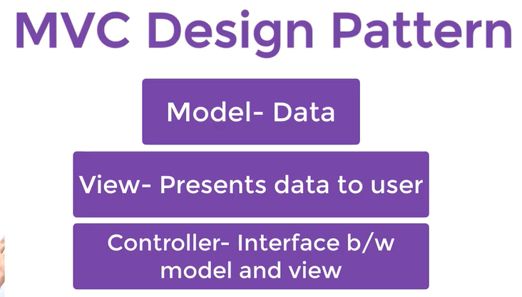

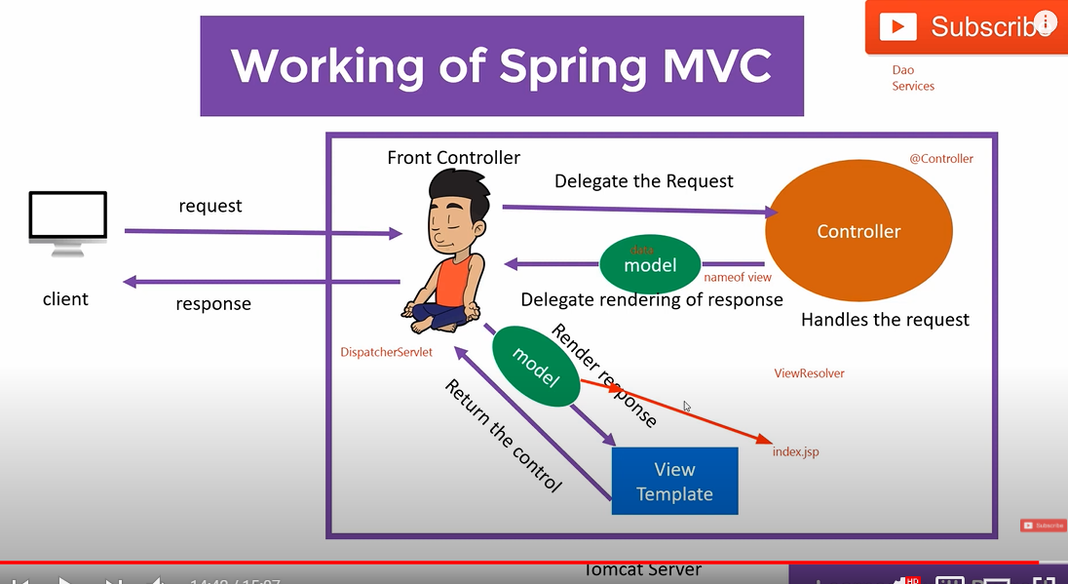

Add this dependency –

<!-- https://mvnrepository.com/artifact/org.springframework/spring-webmvc -->

<dependency>

<groupId>org.springframework</groupId>

<artifactId>spring-webmvc</artifactId>

<version>5.2.8.RELEASE</version>

</dependency>

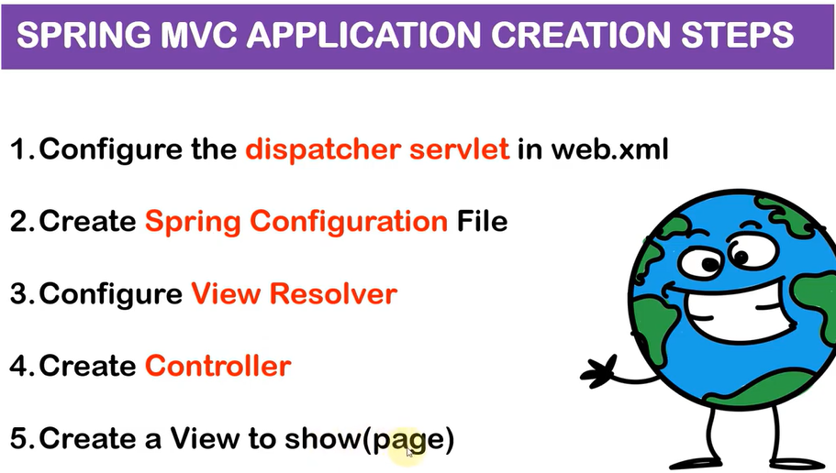

1. In web.xml file

<servlet>

<servlet-name>spring</servlet-name>

<servlet-class>org.springframework.web.servlet.DispatcherServlet</servlet-class>

</servlet>

<servlet-mapping>

<servlet-name>spring</servlet-name>

<url-pattern>/</url-pattern>

</servlet-mapping>

2. In web.inf folder – make spring-servlet.xml file and make views folder and keep index page inside views

<?xml version=*"1.0"* encoding=*"UTF-8"*?>

<beans xmlns=*"http://www.springframework.org/schema/beans"*

xmlns:xsi=*"http://www.w3.org/2001/XMLSchema-instance"*

xmlns:context=*"http://www.springframework.org/schema/context"*

xmlns:p=*"http://www.springframework.org/schema/p"*

xmlns:tx=*"http://www.springframework.org/schema/tx"*

xmlns:util=*"http://www.springframework.org/schema/util"*

xsi:schemaLocation=*"http://www.springframework.org/schema/beans*

*http://www.springframework.org/schema/beans/spring-beans.xsd*

*http://www.springframework.org/schema/context*

*http://www.springframework.org/schema/context/spring-context.xsd*

*http://www.springframework.org/schema/util*

*http://www.springframework.org/schema/util/spring-util.xsd*

*http://www.springframework.org/schema/tx*

*http://www.springframework.org/schema/tx/spring-tx.xsd*

*"*>

</beans>

3. make view resolover

How file path is created ….

<bean class=*"org.springframework.web.servlet.view.InternalResourceViewResolver"*

name=*"viewResolver"*

p:prefix=*"/WEB-INF/views/"*

p:suffix=*".jsp"*

/>

4. make controller for handling request

**package** springmvc.controller;

**import** org.springframework.stereotype.Controller;

**import** org.springframework.web.bind.annotation.RequestMapping;

@Controller

**public** **class** HomeController {

@RequestMapping("/home")

**public** String home() {

System.***out***.println("This is my home page");

**return** "index";

}

}

@Controller- means to get request of controller

@Requestmapping- used to map index page to home request url in views

And add base packages inside spring-servelet.xml

<context:component-scan base-package=*"springmvc.controller"*/>

Sending data from controller to view :

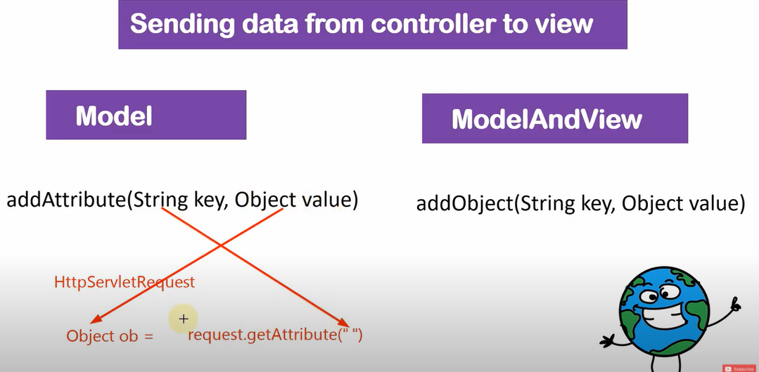

**Model : import** org.springframework.ui.Model;

@Controller

**public** **class** HomeController {

@RequestMapping("/home")

**public** String home(Model model) {

model.addAttribute("name", "Ajay Ingle");

System.***out***.println("This is my home page");

**return** "index";

}}

<html>

<body>

<h2>Welcome!</h2>

<% String name = (String)request.getAttribute("name"); %>

<h1>Your name : <%= name %> </h1>

</body>

</html>

ModelAndView : **import** org.springframework.web.servlet.ModelAndView;

<body>

<h1>Student detail : </h1>

<%

String name = (String) request.getAttribute("name");

**int** d = (Integer) request.getAttribute("id");

%>

<h2>Student name :<%= name %> </h2>

<h2>Student id :<%= d %> </h2>

</body>

</html>

@RequestMapping("/stud")

**public** ModelAndView stud() {

ModelAndView m = **new** ModelAndView();

m.addObject("name", "Vijay Ingle");

m.addObject("id", 123);

m.setViewName("ModelView");

**return** m;

}

If we don’t want to use getAttribute in jsp then used

<%@page isELIgnored=*"false"* %>

<h2>Student name : ${name}</h2>

<h2>Student id : ${id} </h2>

If we want to use JSTL in jsp :

<dependency>

<groupId>jstl</groupId>

<artifactId>jstl</artifactId>

<version>1.2</version>

</dependency>

<%@ taglib prefix=*"c"* uri=*"http://java.sun.com/jsp/jstl/core"* %>

<c:forEach items=*"*${marks}*"* var=*"i"*>

<h3>${i}</h3>

</c:forEach>

List<Float> f = **new** ArrayList<Float>();

f.add(12.9f);

f.add(13.4f);

f.add(45.6f);

m.addObject("marks", f);

Sending data from view to controller :

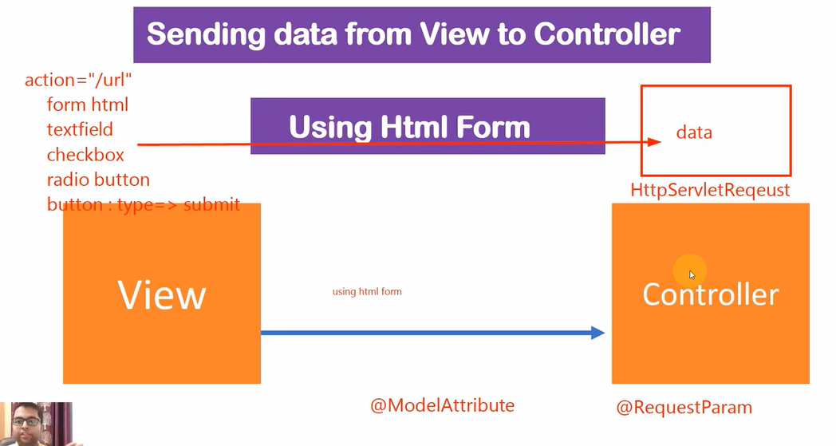

@RequestParam – used to get one field value at time

@ModelAttribute – used to get all field value in class object.

@Controller

@RequestMapping("/demo")

**public** **class** HomeController {

……………………………………….

}

url become - /demo/home and /demo/ModelView here..

Use @RequestParam

@RequestMapping(path="/post_register" , method=RequestMethod.***POST***)

**public** String handlerRegister(

@RequestParam("email") String user_email,

@RequestParam("password") String user_password,

@RequestParam("address") String user_address,

@RequestParam("city") String user_city,

@RequestParam("state") String user_state,

@RequestParam("zip") String user_zip,

@RequestParam("check") String user_check,

Model mregister

)

{

mregister.addAttribute("model_email",user_email);

mregister.addAttribute("model_password",user_password);

mregister.addAttribute("model_address",user_address);

mregister.addAttribute("model_city",user_city);

mregister.addAttribute("model_state",user_state);

mregister.addAttribute("model_zip",user_zip);

mregister.addAttribute("model_check",user_check);

**return** "success";

}

Without @ModelAttribute problem :

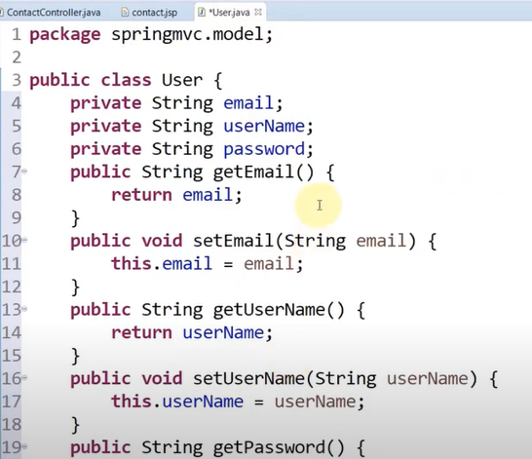

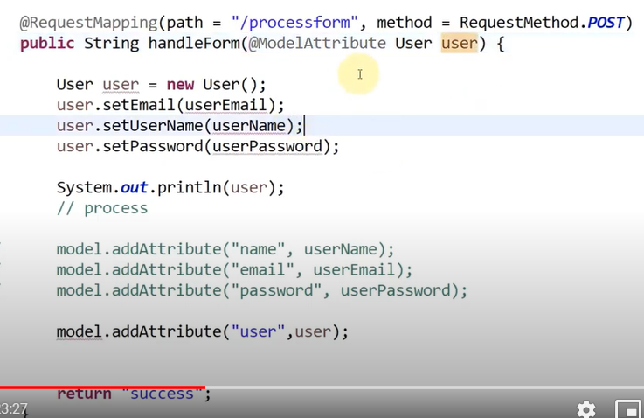

In this you can see we use normal modal to generated user like setter and getter and we used here model to get object of user. But here we need to right all code. So remove this we used @Modelttribute

@RequestMapping(path="/post_register" , method=RequestMethod.***POST***)

**public** String handlerRegister2(@ModelAttribute User user , Model mregister)

{

mregister.addAttribute("u", user);

**return** "success";

}

If u have comman data to print in all pages

@ModelAttribute

**public** **void** commandata(Model m) {

m.addAttribute("title", "This is application");

}

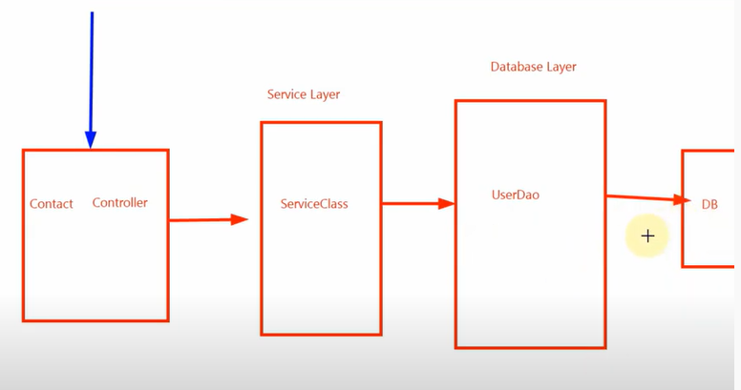

Redirecting in spring mvc :

1. HttpServletResponse 2. Redirect prefix 3. RedirectView

*** Redirect prefix :

@RequestMapping("/one")

**public** String one() {

System.***out***.println("one print");

**return** "redirect:/two";

}

@RequestMapping("/two")

**public** String two() {

System.***out***.println("two print");

**return** "";

}

In this you are simply use redirect:/url_name

*** RedirectView

@RequestMapping("/one")

**public** RedirectView one() {

System.***out***.println("one print");

RedirectView r = **new** RedirectView();

r.setUrl("two");

**return** r;

}

@RequestMapping("/two")

**public** String two() {

System.***out***.println("two print");

**return** "";

}

In this you can used redirectview it use dto redirect in any website like

@RequestMapping("/one")

**public** RedirectView one() {

System.***out***.println("one print");

RedirectView r = **new** RedirectView();

r.setUrl("https://google.com");

**return** r;

}

HttpServelt is not recommended….

If u want to handle errors :

Use this tag lib in jsp

<%@ taglib prefix=*"form"* uri=*"http://www.springframework.org/tags/form"* %>

Alert msg :

<div class=*"alert alert-danger"* role=*"alert"*>

<form:errors path=*"suser.*"* />

</div>

@RequestMapping(path="/post_register" , method=RequestMethod.***POST***)

**public** String handlerRegister2(@ModelAttribute("suser") Users user , BindingResult result, Model mregister)

{

**if**(result.hasErrors()) {

**return** "redirect:/register";

}

……………………………

}

How to insert static file like css/js/img

Spring-servelt :

xmlns:mvc=[*http://www.springframework.org/schema/mvc*](http://www.springframework.org/schema/mvc)

*http://www.springframework.org/schema/mvc*

*http://www.springframework.org/schema/mvc/spring-mvc.xsd*

<mvc:annotation-driven />

<mvc:resources location=*"/WEB-INF/vendor/"* mapping=*"/vendor/**"* />

<body style=*"background: url('*<c:url value=*'/vendor/img/back-search.jpeg'* />*'); background-size: cover; background-repeat: no-repeat;"*>

<link rel=*"stylesheet"* href=*"*<c:url value=*"/vendor/css/style.css"* />*"* >

<script src=*"*<c:url value=*"/vendor/js/main.js"* />*"* ></script>

File Uplaod :

1. Add dependency :

<dependency>

<groupId>commons-fileupload</groupId>

<artifactId>commons-fileupload</artifactId>

<version>1.4</version>

</dependency>

<dependency>

<groupId>commons-io</groupId>

<artifactId>commons-io</artifactId>

<version>2.8.0</version>

</dependency>

2. <bean name=*"multipartResolver"* class=*"org.springframework.web.multipart.commons.CommonsMultipartResolver"* />

@Pathvariable :



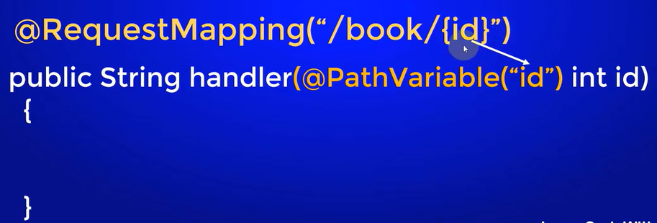

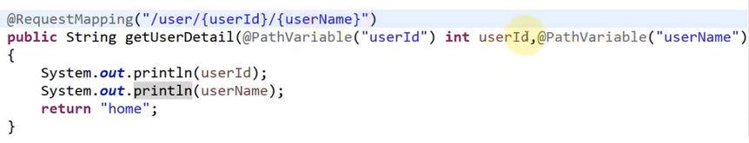

Exceptions : It is used in single controller :

Single exception handle:create null_page which error page in jsp

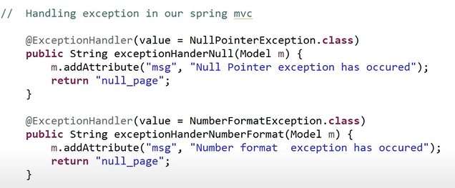

All exception handle :

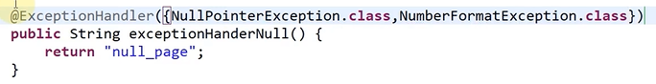

Send Response status code with exception it is useful in rest api

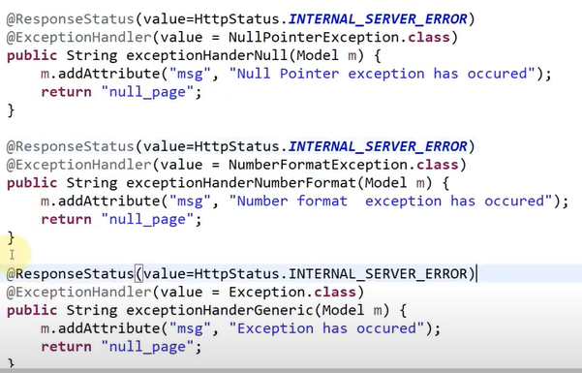

Exception : It is used all controller make centerliazed controller

Make new class with myexceptionhandle and make annotation @ControllerAdvice so that it knows that exception handle by this controller of other controller

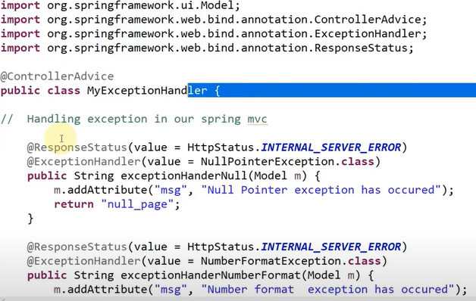

Spring Interceptor :

If you ant to do any process before actual request processing.

It can used in three place

1. before Handler

2. After Handler

3. After View

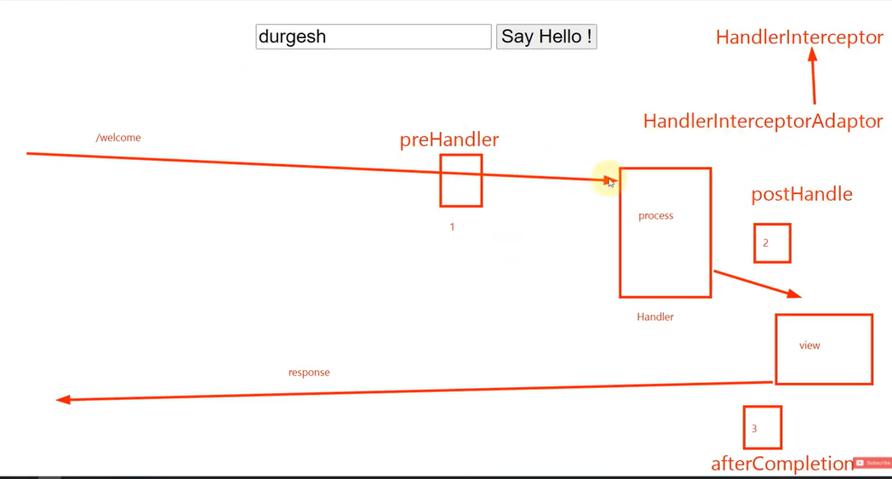

If u want override all method then class implement HandlerInterceptor or otherwise if u want specific handler or service like only pre handle then use class extends HandlerInterceptorAdaptor.

// create table for search application project :

Hibernate: create table kengine (rid integer not null, Engine varchar(255)) engine=InnoDB

Hibernate: create table reg_add (radd_id integer not null auto_increment, City varchar(255), State varchar(255), primary key (radd_id)) engine=InnoDB

Hibernate: create table reg_user (rid integer not null auto_increment, DOB datetime(6), Email varchar(255), Gender varchar(255), Name varchar(255), Password varchar(255), ConfirmPassword varchar(255), Profile tinyblob, address_radd_id integer, primary key (rid)) engine=InnoDB

Hibernate: alter table kengine add constraint FKd53ppy5iunjb3g2op7d8ls22g foreign key (rid) references reg_user (rid)

Hibernate: alter table reg_user add constraint FKrnuwarqcfx5m9l4emrnj9inio foreign key (address_radd_id) references reg_add (radd_id) on delete cascade

// you want to use list of string in register class

@ElementCollection

@CollectionTable(name="kengine", joinColumns=@JoinColumn(name="rid"))

@Column(name = "Engine")

**private** List<String> fengine;

// Make address as forgine key

@Autowired

@OneToOne(cascade = {CascadeType.***ALL***})

@OnDelete(action = OnDeleteAction.***CASCADE***)

**Spring AOP**

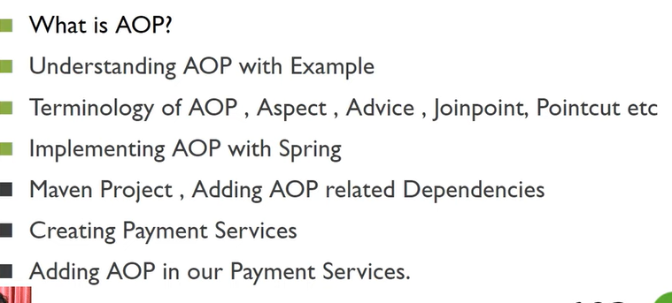

AOP is Aspect oriented programming.

Write your aop before and after service without modifying code.

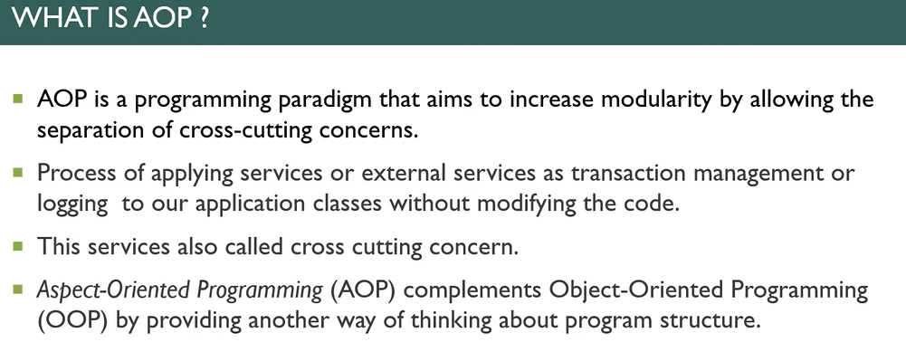

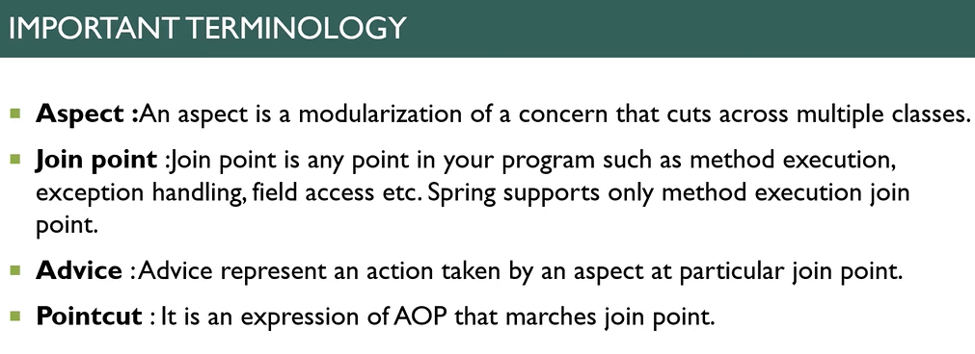

Dependency – spring aop, aspectjrt, aspectjweaver

It is used when you need not change the function code and you want before and after logic then use aop

<aop:aspectj-autoproxy/>

@Aspect

**public** **class** MyAspect {

// * means all return type

@Before(value = "execution(* com.ingle.service.PaymentServicesImp.makepayment(..))")

**public** **void** printBefore() {

System.***out***.println("Payment started..");

}

@After(value = "execution(* com.ingle.service.PaymentServicesImp.makepayment(..))")

**public** **void** printAfter() {

System.***out***.println("Payment close..");

}

}

Spring Boot

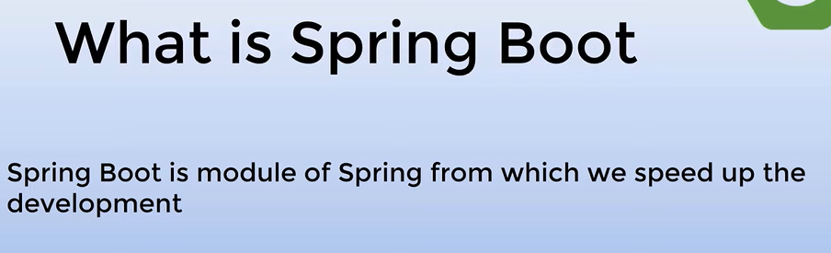



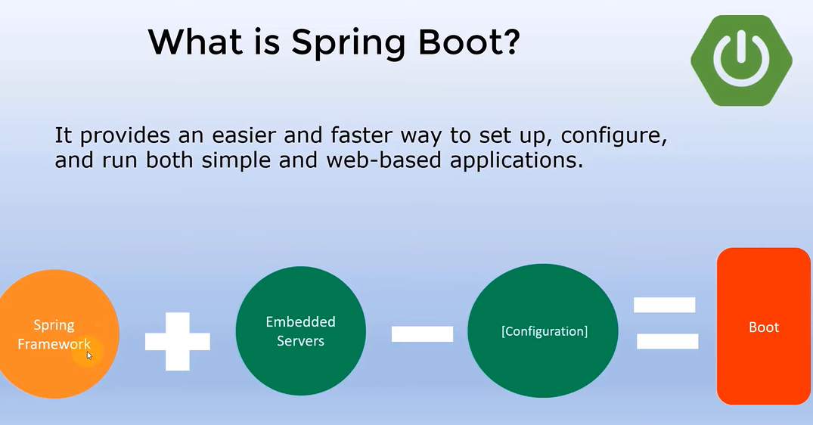

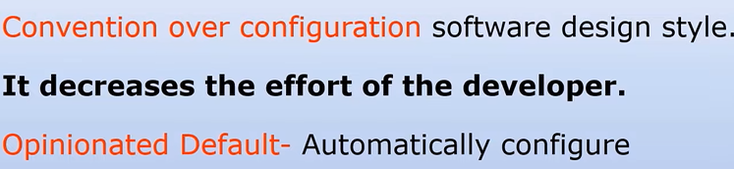



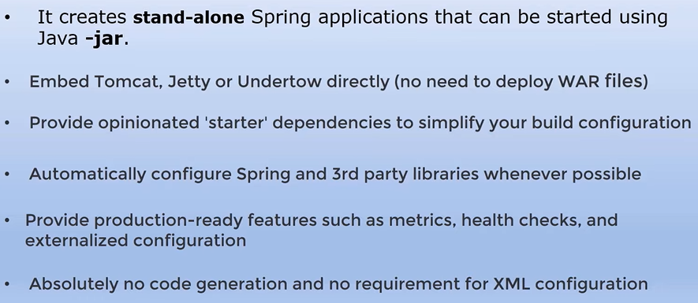

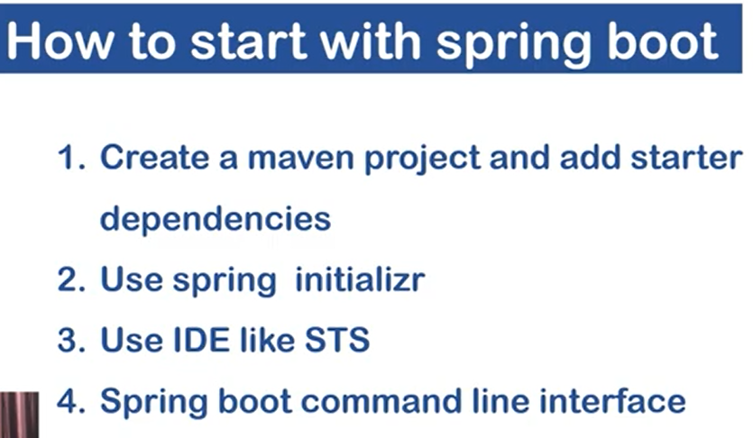

@SpringBootApplication => @configuration, @EnableAutoConfiguration , @ComponentScan

application.properties used for writing details about server port and mysql conn …

mvnw – command line use .

used spring initializer :

1. make zip file and import in eclipse

2. make new port server.port = 9192 in application.properties

3. simple run.

Run jsp in spring boot:

Make folder inside – main – webapp – views – index.jsp

spring.mvc.view.prefix=/views/

spring.mvc.view.suffix=.jsp

make new controller – and test.

@Controller

**public** **class** TestController {

@RequestMapping("/")

**public** String test() {

**return** "index";

}

}

Application.yml is also same as application.propeties.

JPA - > java persistence api –

1. persistence - permently store

### 2.

JPA :-> 1) JPA stands for Java Persistence API

2) JPA is just a specification and hibernate is a kind of implementation so that we can map our class to table by annotations or by XML

3) if you want to use JPA then you need to add spring-boot-starter-data-jpa dependency

4) we need data base layer to talk with database so that we needs to create a interface(you can give any name here we use UserRepository for standard) that extends CRUDRepository or JPARepository to get some inbuild methods from spring boot

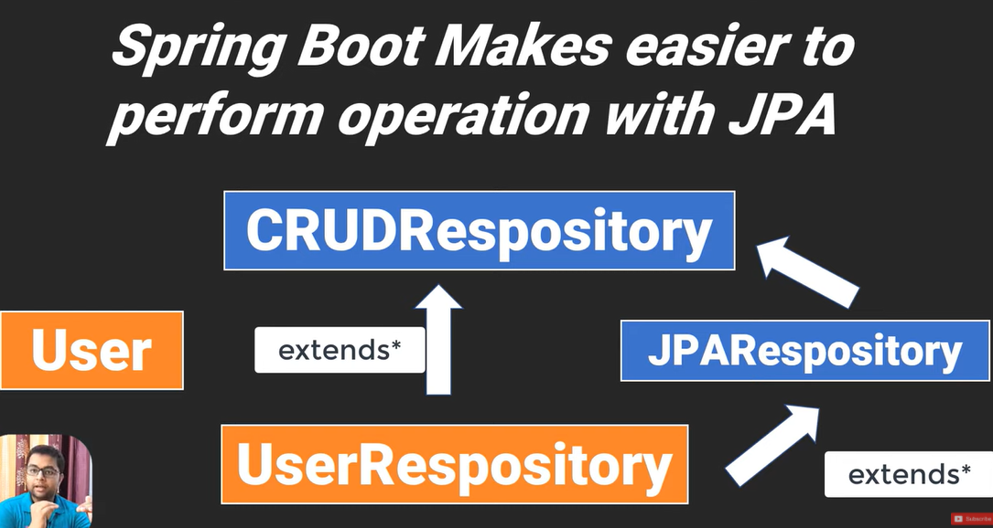

1. make application of crud in springboot.- console based;

-> make your packages name as com.sboot.jpa.model or com.sboot.jpa.dao if SpringApplication name is com.sboot.jpa – no need of EnableJpaRepository annotation.

*********Custom finder methods or driver query methods:***************

Like let’s we want to get student data by name but in Crudrepo will give default three or four methods not all. So it’s need.

findBySname - > Sname is your properties

In this you are not creating query , create query by methods only.

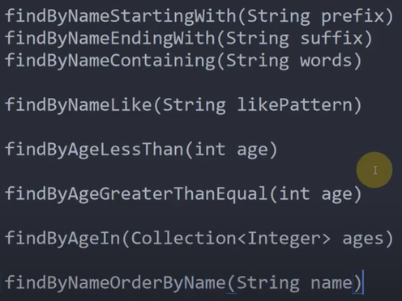

***********JPQL and Native Query *********************************

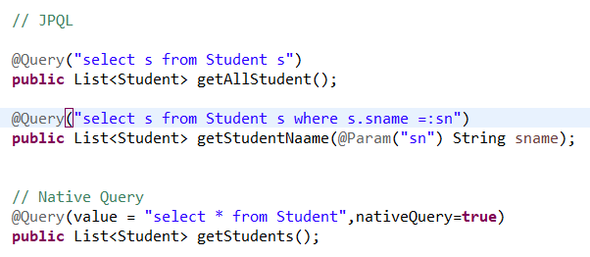

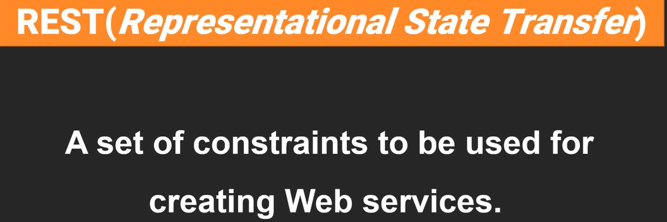

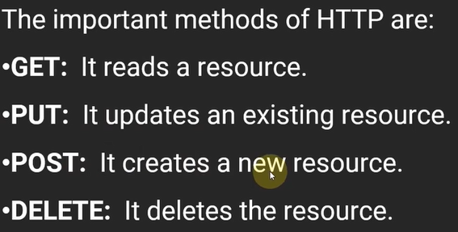

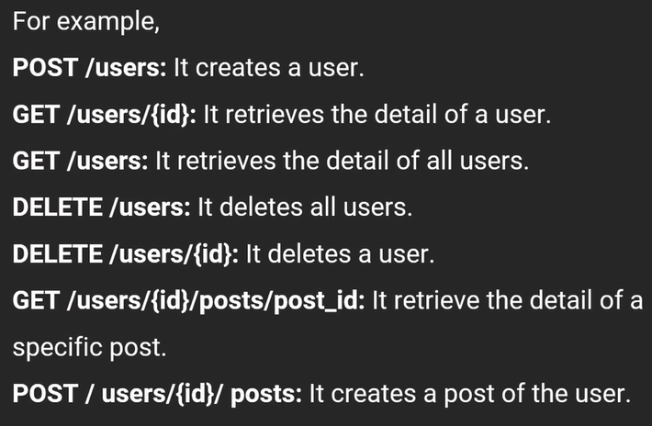

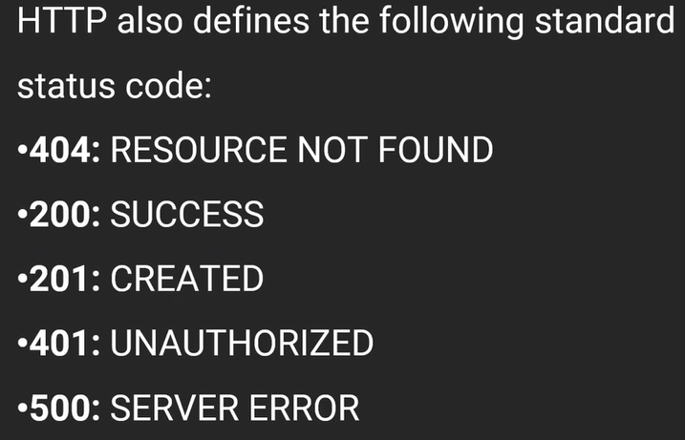

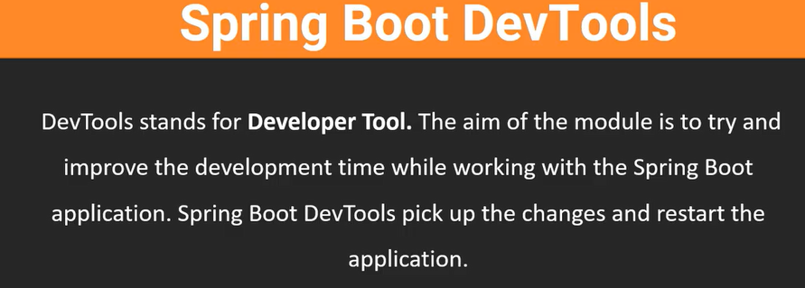

It used to restart springboot application automatically.

Features of devtools in spring boot:

1. property defaults: Automatic false cache data. It automatically reflect data on browser.

2. Automatic restart : It scan the class when modification is done then it restart server automatically.

3. Live Reload : It reload automatic.

RestApi :

@RestController - > make rest controller

@GetMapping(“/books”)

@GetMapping(“/books/{id}”)

@PostMapping(“/books”)

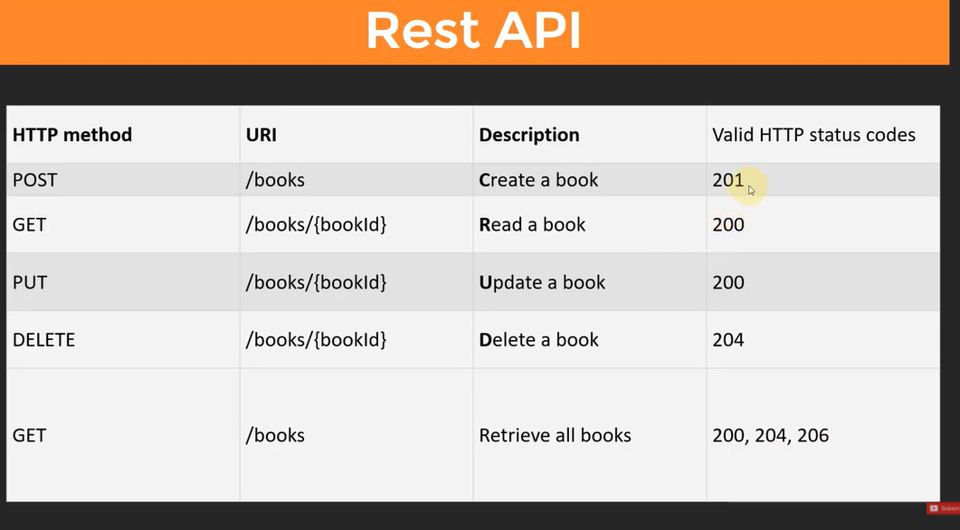

Thymeleaf – used to make interactive templates…

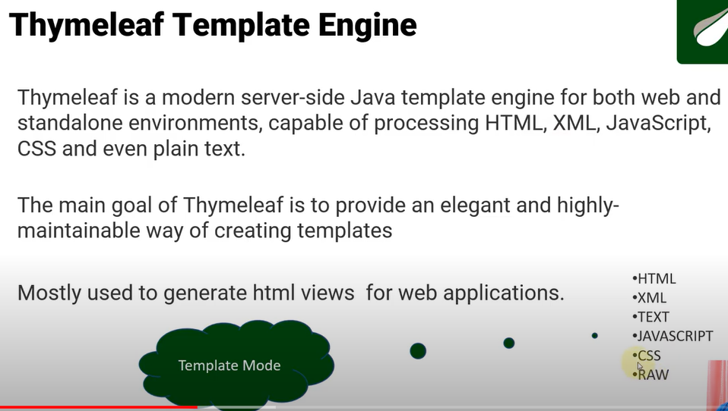

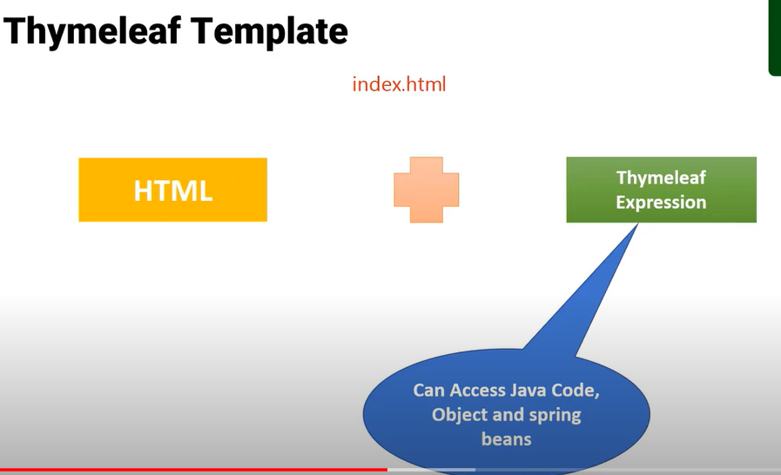

JSP - it is not template engine because whenever we created jsp it is used to convert into servlet and then run. And also it has file extension is JSP

Thymeleaf – it is template engine and it takes html file and produce dynamic content to web and it has file extension as HTML.

Download thymleaf –

https://www.thymeleaf.org/eclipse-plugin-update-site/

Emment for fast html writing –

<https://github.com/emmetio/emmet-eclipse>

**Thymeleaf :**

**Replace – just rplace content from one html to another**

**Insert – it just insert data inside any tag**

**Include – same as insert but exclude host tag**

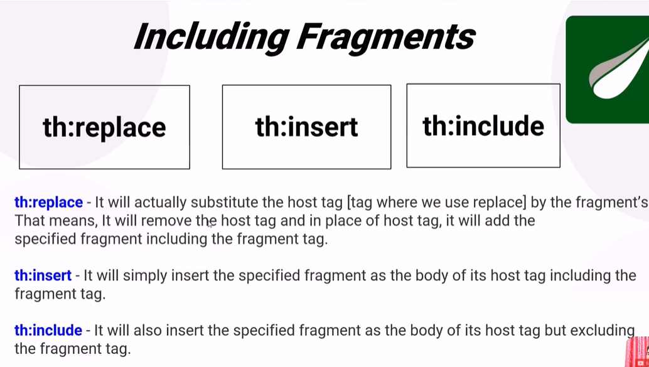

**Smart Contact Manager project:**

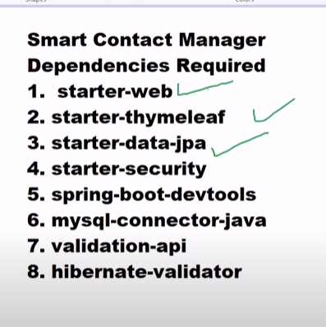

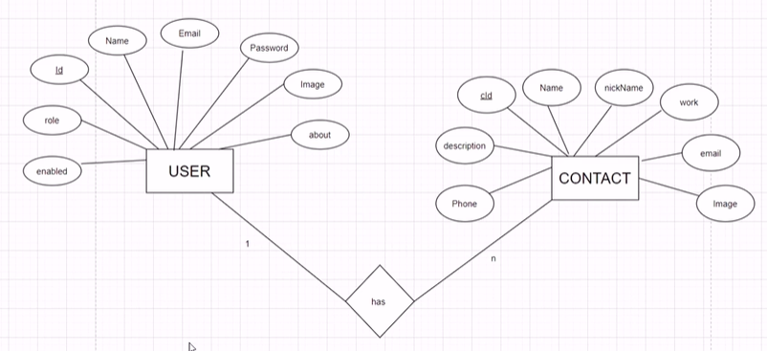

**Spring security :**

<dependency>

<groupId>org.springframework.boot</groupId>

<artifactId>spring-boot-starter-security</artifactId>

</dependency>

**Spring security has userDetails interface in which we have getusername() and getpassword()**

**Steps on spring security :**

**UserRepositroy – create getusername function and query :**

@Query("select u from User u where u.email =: email")

**public** User getUserByUserName(@Param("email") String email)

**Make CustomDetails implement by UserDetails :**

**package** com.smartcontact.config;

**import** java.util.Collection;

**import** java.util.List;

**import** org.springframework.security.core.GrantedAuthority;

**import** org.springframework.security.core.authority.SimpleGrantedAuthority;

**import** org.springframework.security.core.userdetails.UserDetails;

**import** com.smartcontact.models.User;

**public** **class** CustomUserDetails **implements** UserDetails{

**private** User user;

**public** CustomUserDetails(User user) {

**super**();

**this**.user = user;

}

@Override

**public** Collection<? **extends** GrantedAuthority> getAuthorities() {

SimpleGrantedAuthority simpleGrantedAuthority = new SimpleGrantedAuthority(user.getRole());

**return** List.*of*(simpleGrantedAuthority);

}

@Override

**public** String getPassword() {

**return** user.getPassword();

}

@Override

**public** String getUsername() {

**return** user.getEmail();

}

@Override

**public** **boolean** isAccountNonExpired() {

**return** **true**;

}

@Override

**public** **boolean** isAccountNonLocked() {

**return** **true**;

}

@Override

**public** **boolean** isCredentialsNonExpired() {

**return** **true**;

}

@Override

**public** **boolean** isEnabled() {

**return** **true**;

}

}

**Make customuserdetils Serviceimpl**

**package** com.smartcontact.config;

**import** org.springframework.beans.factory.annotation.Autowired;

**import** org.springframework.security.core.userdetails.UserDetails;

**import** org.springframework.security.core.userdetails.UserDetailsService;

**import** org.springframework.security.core.userdetails.UsernameNotFoundException;

**import** com.smartcontact.dao.UserRepository;

**import** com.smartcontact.models.User;

**public** **class** CustomUserDetailsServiceImpl **implements** UserDetailsService {

@Autowired

**private** UserRepository userRepository;

@Override

**public** UserDetails loadUserByUsername(String username) **throws** UsernameNotFoundException {

User user = **this**.userRepository.getUserByUserName(username);

**if**(user == **null**) {

**throw** **new** UsernameNotFoundException("Username is not found");

}

CustomUserDetails customUserDetails = **new** CustomUserDetails(user);

**return** customUserDetails;

}

}

**Make spring security configuration:**

**package** com.smartcontact.config;

**import** org.springframework.context.annotation.Bean;

**import** org.springframework.context.annotation.Configuration;

**import** org.springframework.security.authentication.dao.DaoAuthenticationProvider;

**import** org.springframework.security.config.annotation.authentication.builders.AuthenticationManagerBuilder;

**import** org.springframework.security.config.annotation.web.builders.HttpSecurity;

**import** org.springframework.security.config.annotation.web.configuration.EnableWebSecurity;

**import** org.springframework.security.config.annotation.web.configuration.WebSecurityConfigurerAdapter;

**import** org.springframework.security.core.userdetails.UserDetailsService;

**import** org.springframework.security.crypto.bcrypt.BCryptPasswordEncoder;

@Configuration

@EnableWebSecurity

**public** **class** SpringSecurityConfig **extends** WebSecurityConfigurerAdapter{

@Bean

**public** UserDetailsService getUserDetailsService() {

**return** **new** CustomUserDetailsServiceImpl();

}

@Bean

**public** BCryptPasswordEncoder passwordEncoder() {

**return** **new** BCryptPasswordEncoder();

}

@Bean

**public** DaoAuthenticationProvider authenticationProvider() {

DaoAuthenticationProvider daoAuthenticationProvider = **new** DaoAuthenticationProvider();

daoAuthenticationProvider.setUserDetailsService(**this**.getUserDetailsService());

daoAuthenticationProvider.setPasswordEncoder(passwordEncoder());

**return** daoAuthenticationProvider;

}

// configuration methods

@Override

**protected** **void** configure(AuthenticationManagerBuilder auth) **throws** Exception {

auth.authenticationProvider(authenticationProvider());

}

// protect only specific urls

@Override

**protected** **void** configure(HttpSecurity http) **throws** Exception {

http.authorizeRequests().antMatchers("/admin/**").hasRole("ADMIN")

.antMatchers("/user/**").hasRole("USER")

.antMatchers("/**").permitAll().and().formLogin().and().csrf().disable();

}

}

